Strategy Pattern Verification
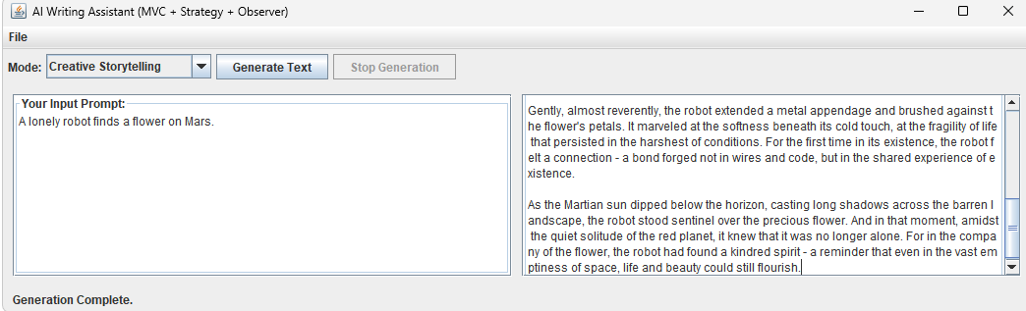
Saving session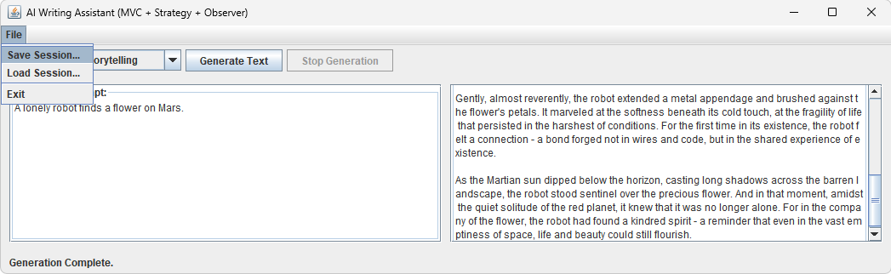
Saving session
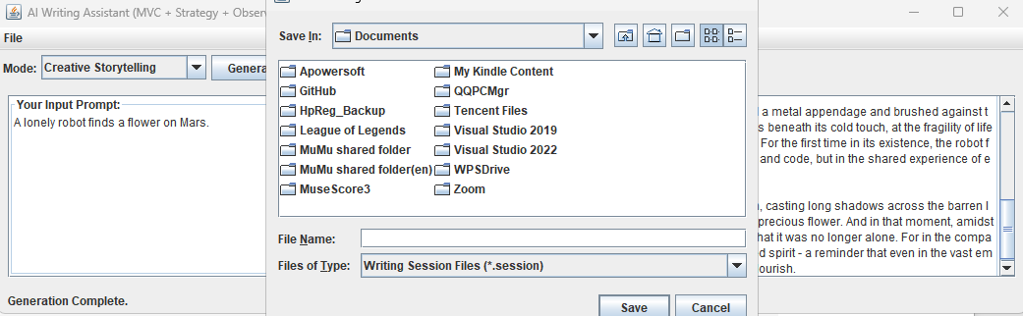
Formal academic report

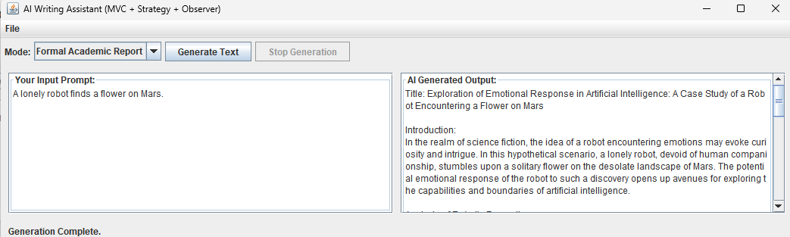
Saving session
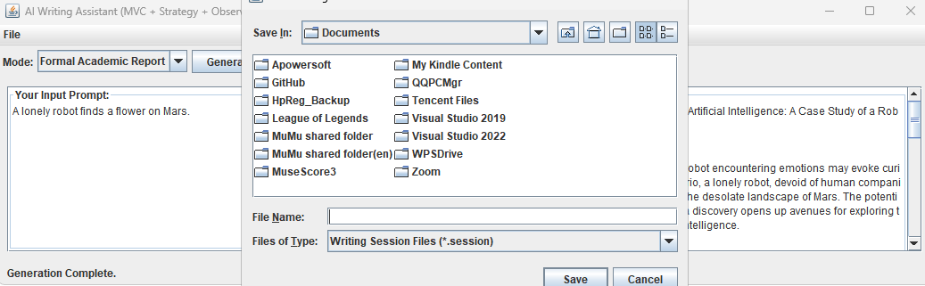
Repository Pattern Verification
Saving session:
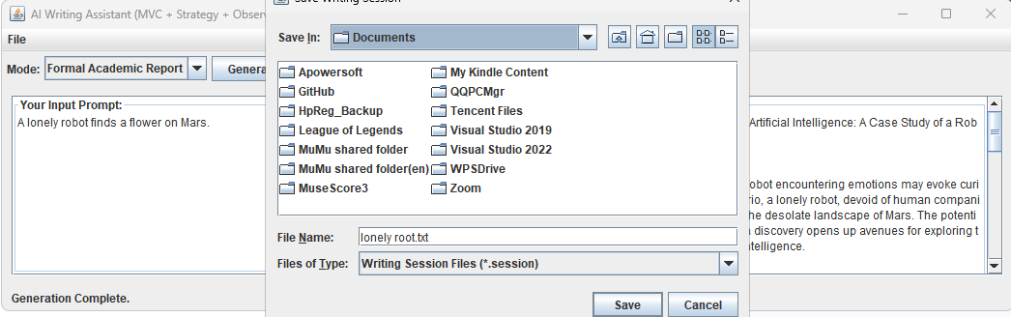
Loading session:
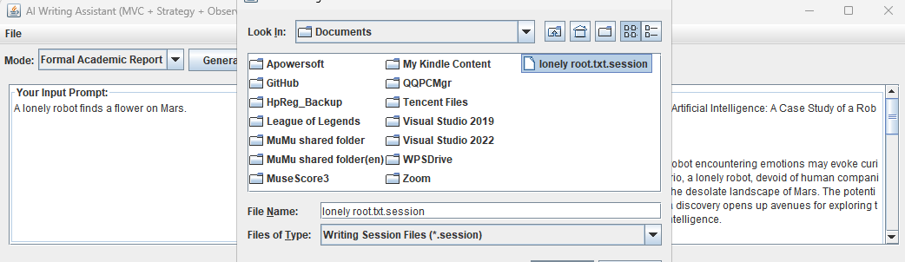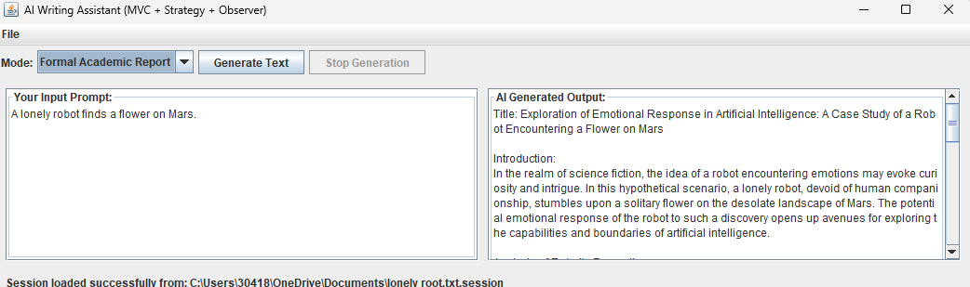Concurrency and Resiliency Tests

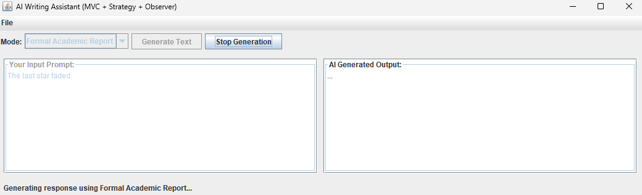
When clicking the generate text button, the button immediately grayed out and disabled, only stop generation available.
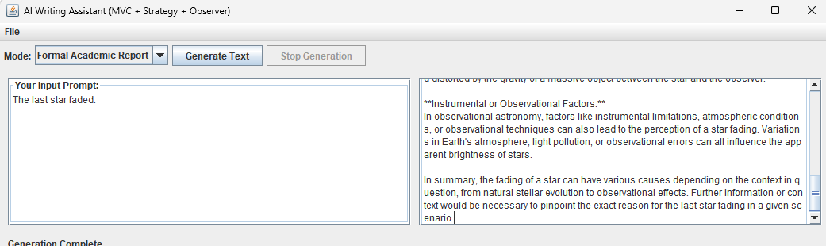
Cancellation Verification (Non-functional Requirement)
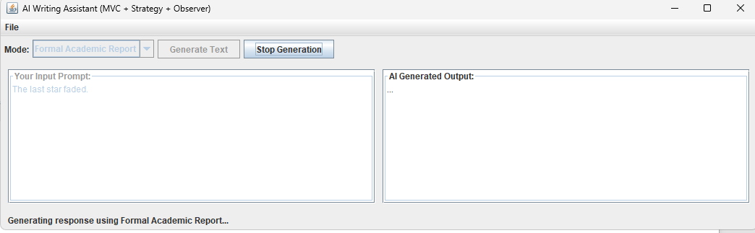
While generating, immediately click stop generation will stop generation.
